Aia Al-Qasab

T5616SN

Advanced Enterprise Server Environment

Lab 1

**Lab 1.**  **Introduction to Microsoft Hyper-V**

January 2019



**Lab 1. Introduction to Microsoft Hyper-V**

**Step 1. Explore the Hyper-V settings and configure virtual networking**

- Start **WinServer-DC** and **wait for the log in screen to appear** before starting the other VMs (no need to login, the server is just needed to provide the domain authentication for the other computers).

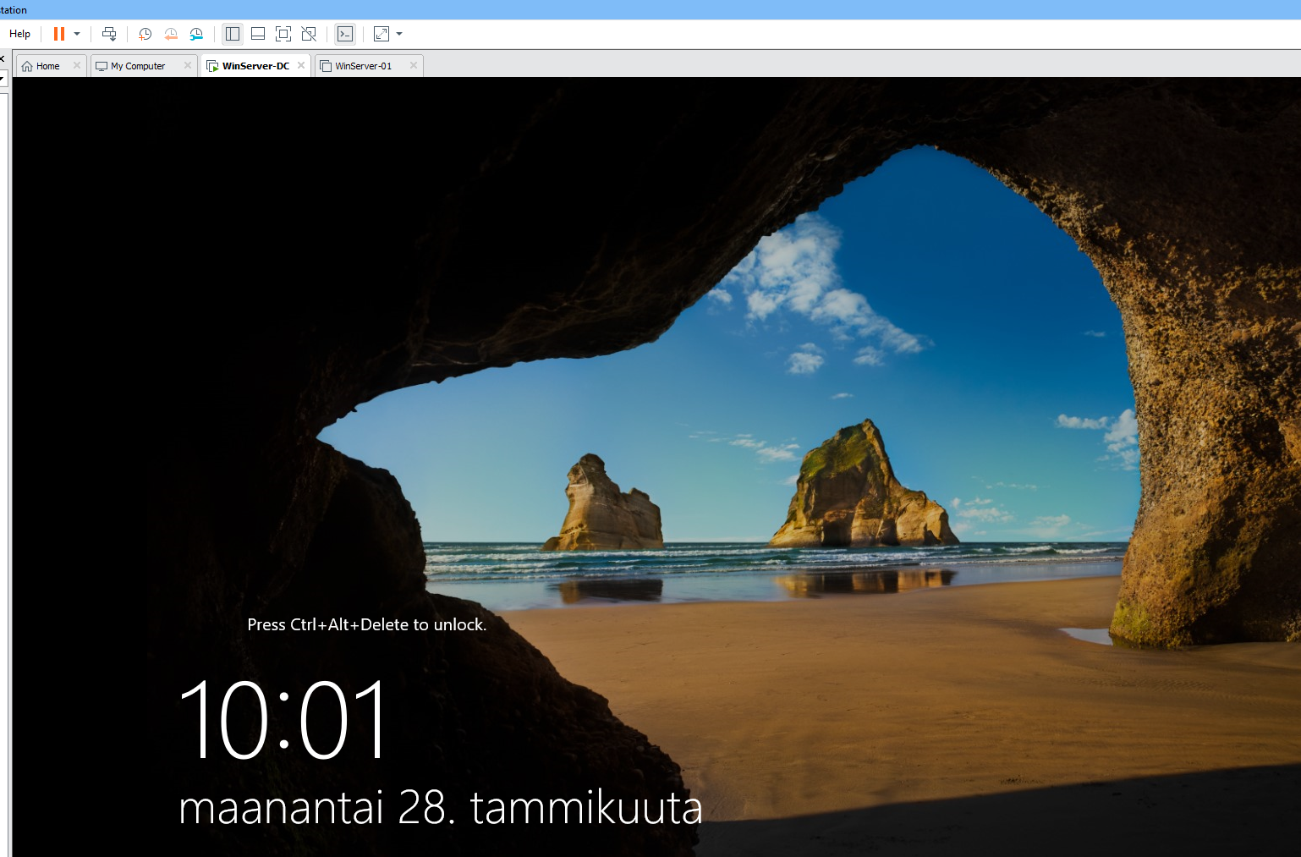

- Start **WinServer-01** and log in as **MAMKLAB\Administrator** / **P@ssw0rd**

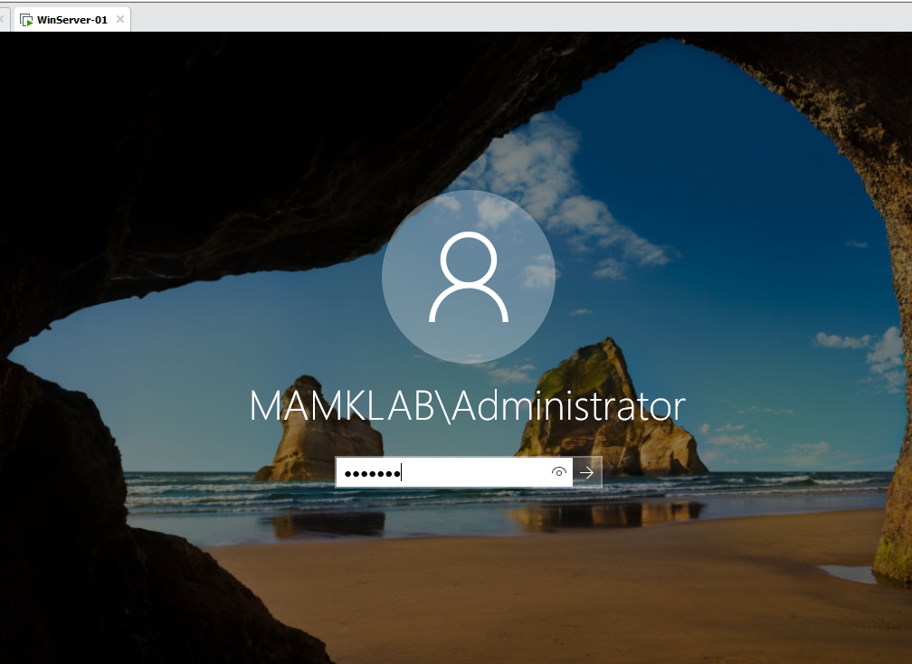

- WinServer-01 already has the **Hyper-V** role installed

- Open **Hyper-V Manager**

o Select **WinServer-01** and examine the **Hyper-V Settings** (in the **Actions** pane/menu)

▪ Note the directories where the virtual machines and their hard disks are stored

▪ Also notice the mouse release key (*CTRL+ALT+LEFT ARROW*)

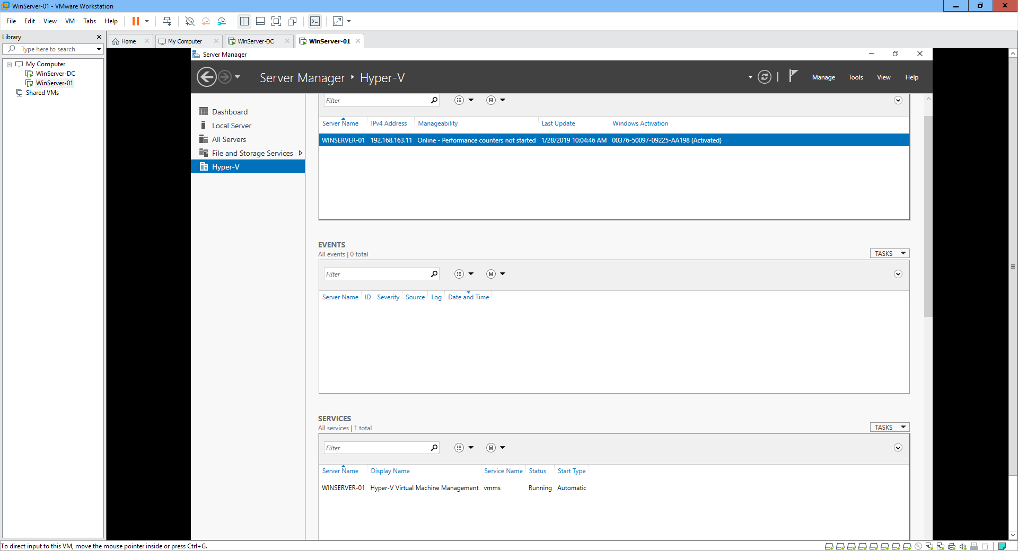

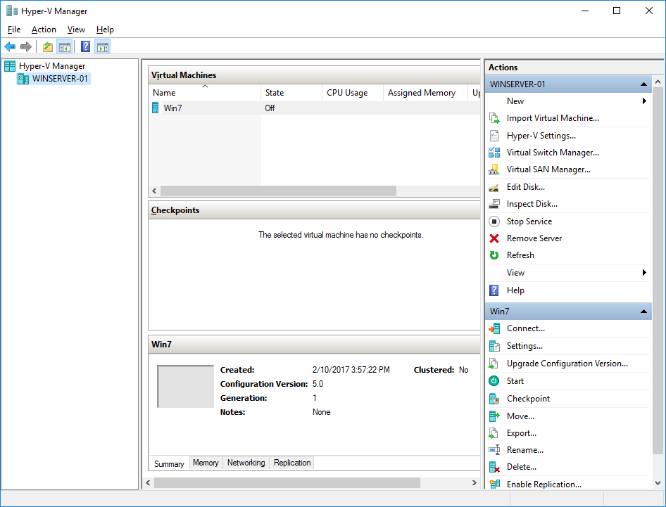

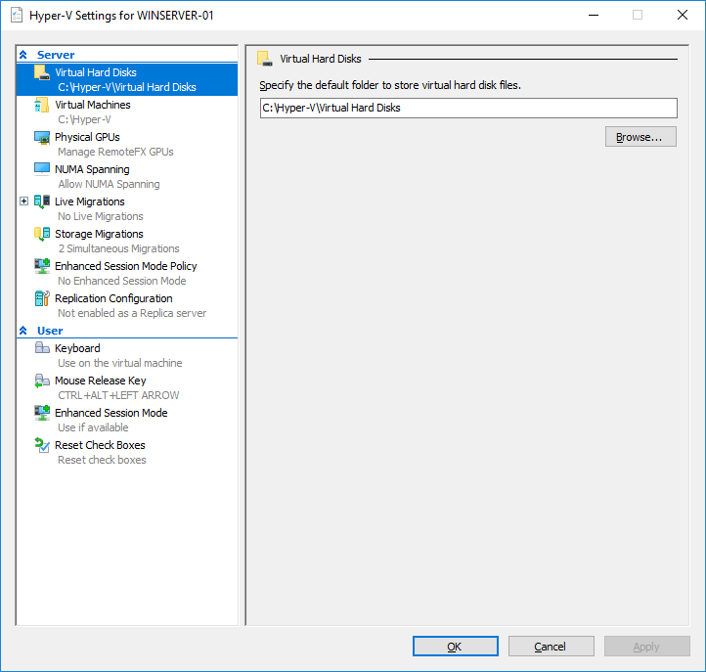

- Before creating any virtual machines, let’s check the server network configuration and the virtual network options.

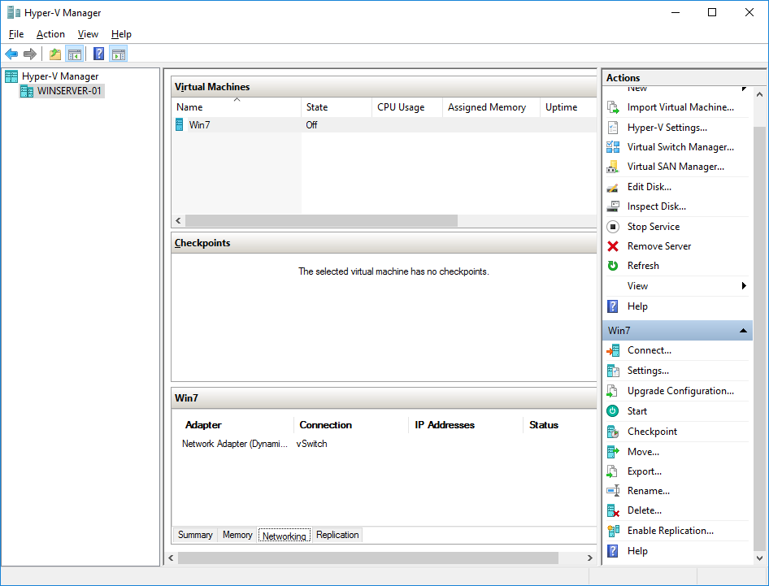

- Open the server network settings and check the adapters. There are two physical adapters, which are currently configured as a team.

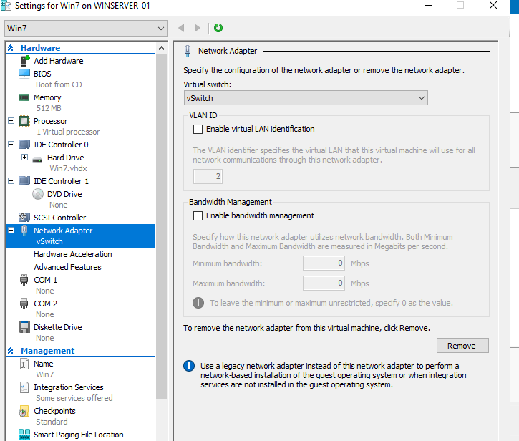

- Open the **Virtual Switch Manager**

o Notice that there is already one virtual switch: **vSwitch**.

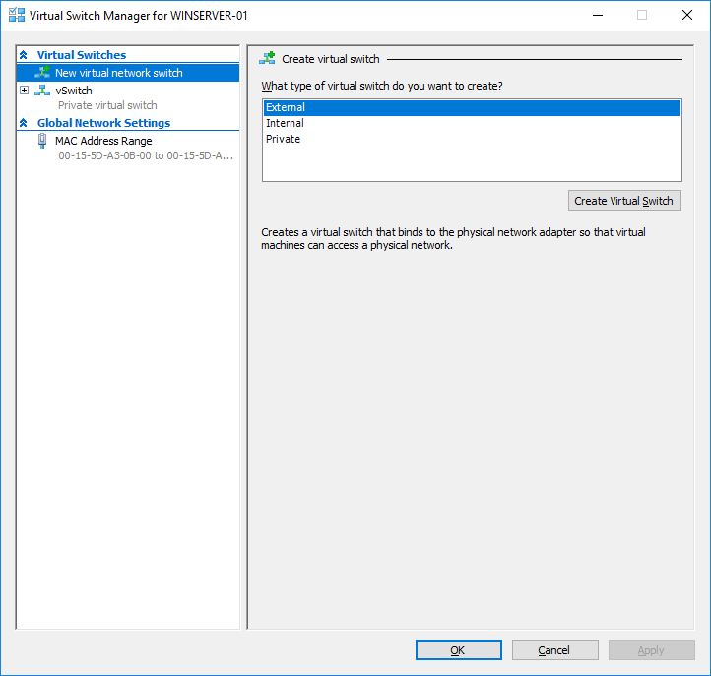

o Study the types of virtual switches: **External virtual network switch**, **Internal virtual network switch** and **Private virtual network switch**.

o *In* ***your report****, explain what type of switch the* ***vSwitch*** *is and what does it mean in practice. Also explain the differences between the* ***external****,* ***internal*** *and* ***private*** *switches. Give some examples for what kind of purposes you would use each of them.*

**A:** **A virtual switch is a software application that allows communication between virtual machines, it does more than just forward data packets and intelligently directs the communication on a network by checking data packets before moving them to a destination.**

**External switch: is bound to the networking protocol stack in the host OS and connected to a physical network interface adapter in the Hyper-V server. Virtual machines running on the serve’s partitions can all access the physical network to which the physical adapter is connected.**

**Internal switch: is bound to a separate instance of the networking protocol stack in the host OS independent from the physical network interface adapter and its connected network. VMs server’s partition can access the virtual network implemented by the virtual switch.**

**Private switch: it exists inly in the Hyper-V server and is accessible only to the VMs running on the child partitions, the host OS can access the physical network through the network interface adapter, but it can’t access the virtual network created by the virtual switch.**

**Internal and private virtual switch are used in the creation of backbone segments for virtual servers, it’s good for security because backbone traffic never traverses the physical network. The internal switch is used sometimes by firewalls as a way of preventing a VM from being directly exposed to the physical network.**

* Create the following virtual network switches:

o **Private virtual network switch** with the name **Private Network** and connection type **Private network**

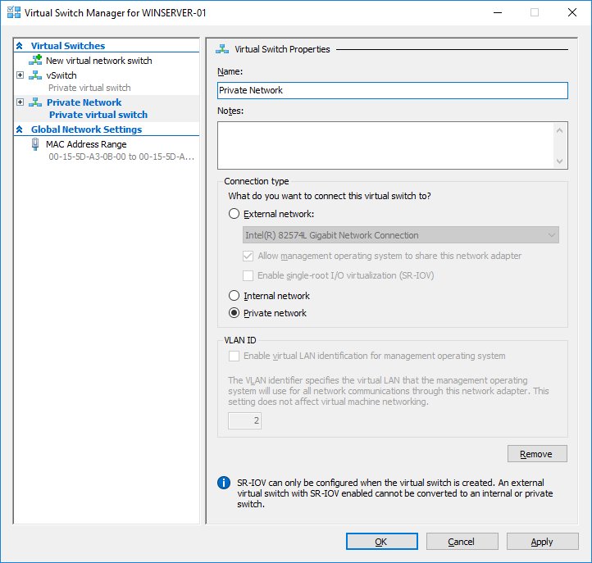

o **Internal virtual network switch** with the name **Internal Network** and connection type **Internal network**

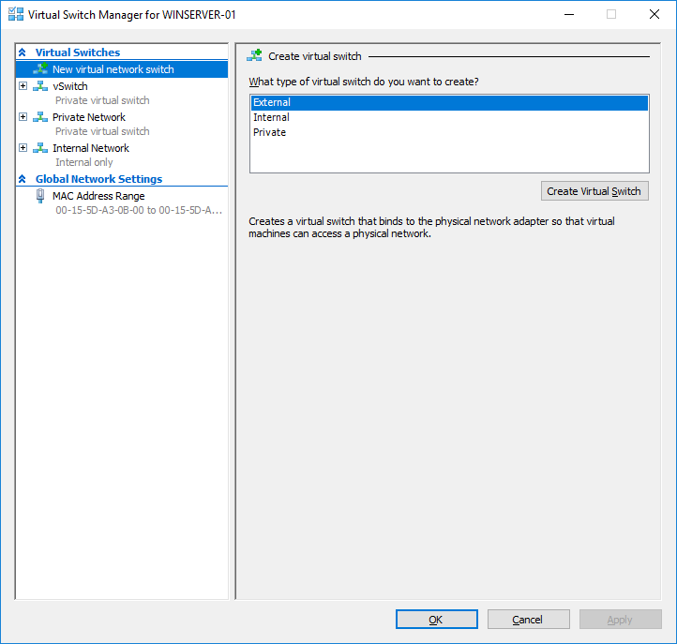

o **External virtual network switch** with the name **Corporate Network** and connection type **External network**. Because the server network adapters are configured as a team and used together by the server, you need to use the **Microsoft Network Adapter Multiplexor Driver** instead of individual adapters.

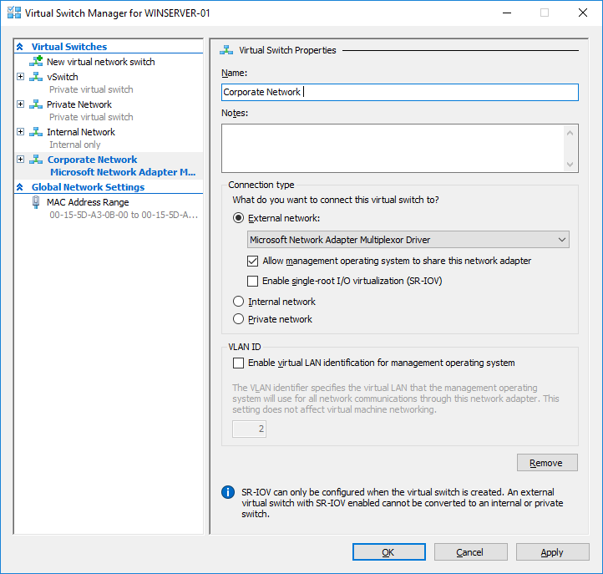

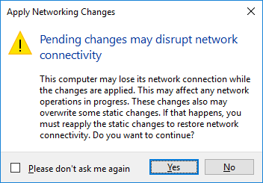

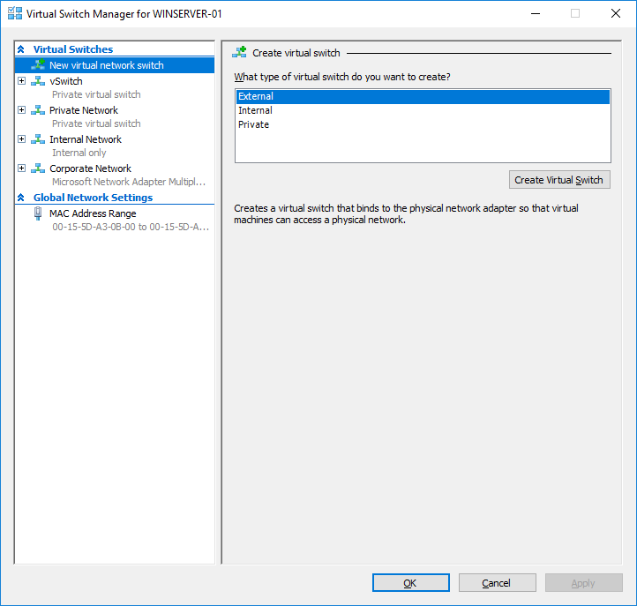

**Step 2. Creating and configuring new virtual machines**

- In **WinServer-01 Hyper-V Manager**, create a new virtual machine with the following settings:

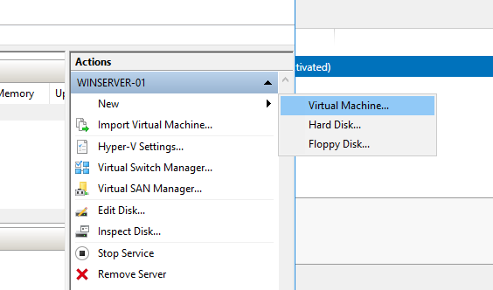

o Name **VM-YourName**

o Location **C:\Hyper-V\**

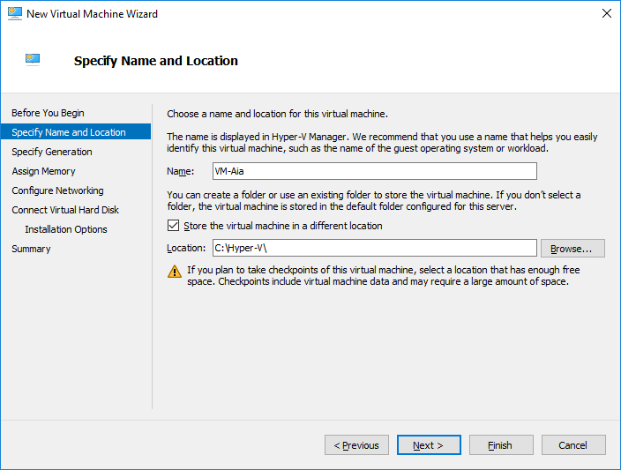

o Specify generation **Generation 1**

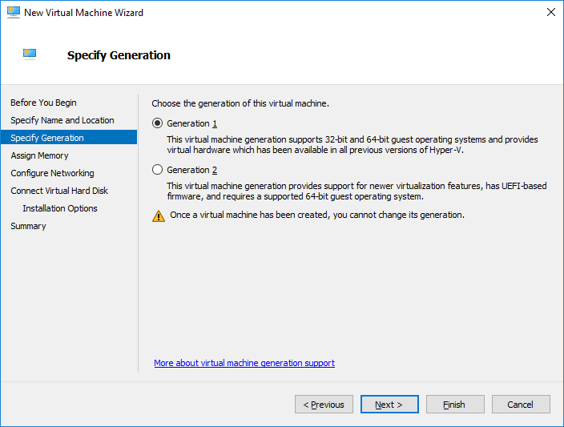

*In* ***your report****, explain what does the VM generation mean? What are the differences between them and when should you use each?*

**A:** **VM generation can be defined as the hardware and functionality that is available on the virtual machine, Windows server Hyper -V includes two types of VMs generation: 1, 2**

**Generation 1: It can support legacy drivers and BIOS based Architecture, it can only initialize the IDE controller for OS. There are no changes in Hardware and functionality.**

**Generation 2: It can only be created in Windows server, if it’s selected then it can’t go back to the precious version, no backward compatibility.**

o Startup Memory **256 MB**, **Use Dynamic Memory for this virtual machine**

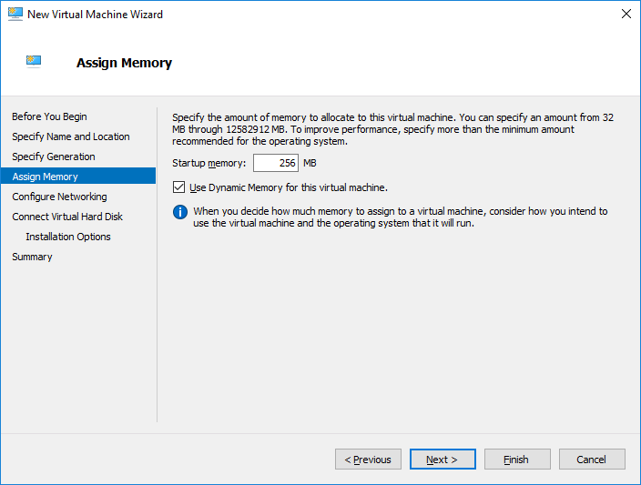

*In* ***your report****, explain what does the Dynamic Memory mean? What kind of risks you may have with Dynamic Memory?*

**A: Dynamic Memory is a new Hyper -V feature that helps to use physical memory more efficiently, Hyper -V treats memory as a shared resource that can be reallocated automatically among running virtual machines. It adjusts the amount of memory available to a virtual machine based on changes in memory demand and values that specify.**

**Dynamic risks: Dynamic doesn’t page, it can’t achieve the densities of other methods, and if hyper doesn’t have enough memory to start a virtual machine it stays off.**

o Connection **Corporate Network**

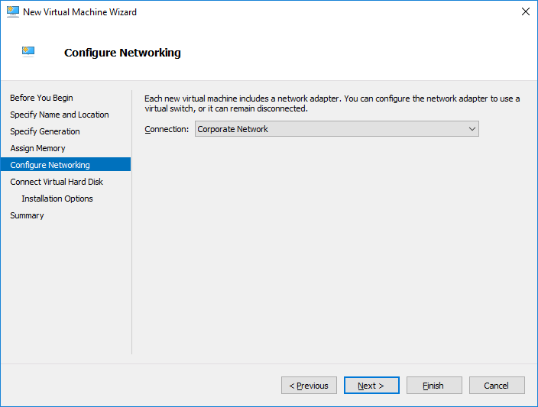

o Disk size **20 GB**

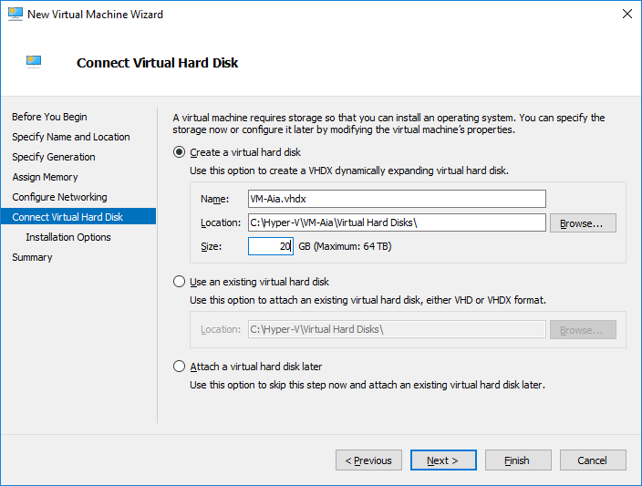

o Install operating system later

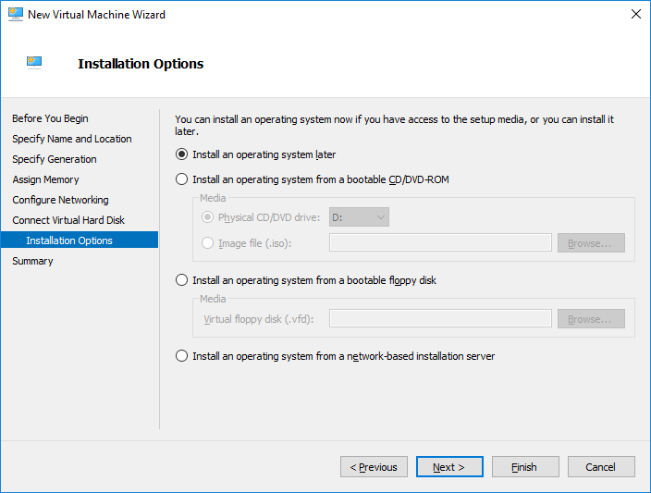

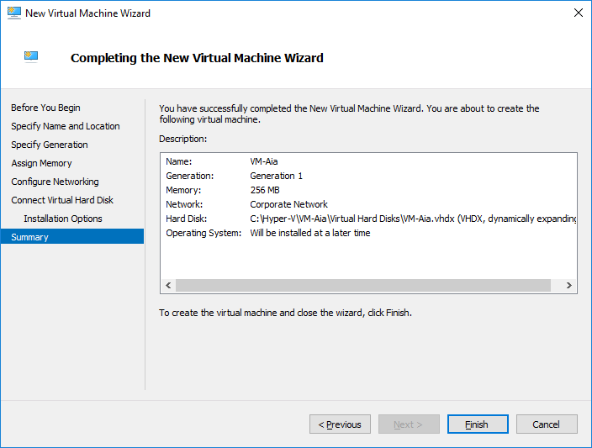

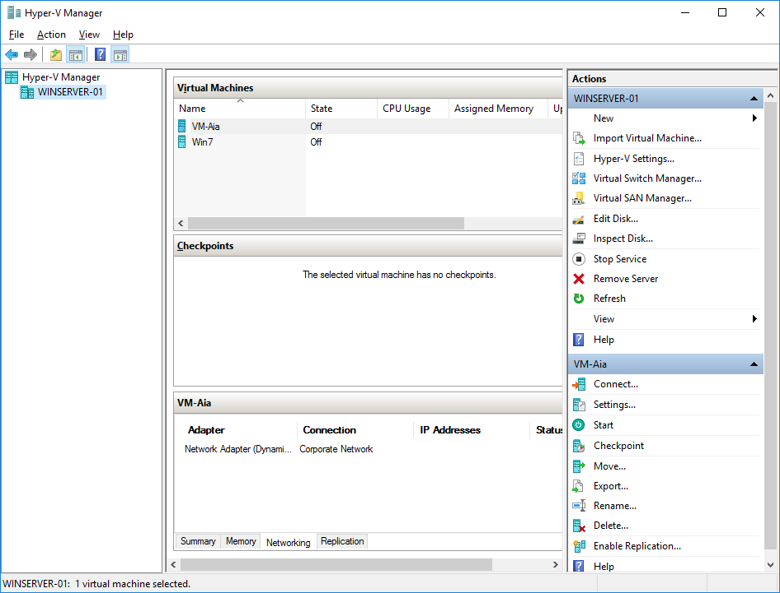

- Use Windows File Explorer to browse to **P:\Matti\ISO** (use the **Student** / **student** account, if prompted for authentication) and **mount a Linux installation DVD** to a DVD drive (you can select which distribution you wish to use, also notice the **drive letter** where the images was mounted)

o In case you have trouble connecting to the P-drive, you can use the server’s name (\\mb3) or it’s IP (\\172.16.1.30)

o Alternatively, you can copy the image file to the local computer and mount it from there.

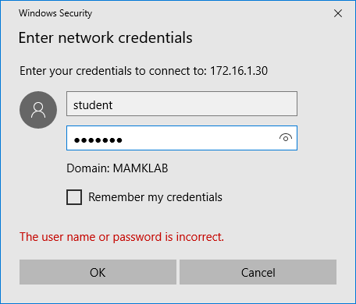

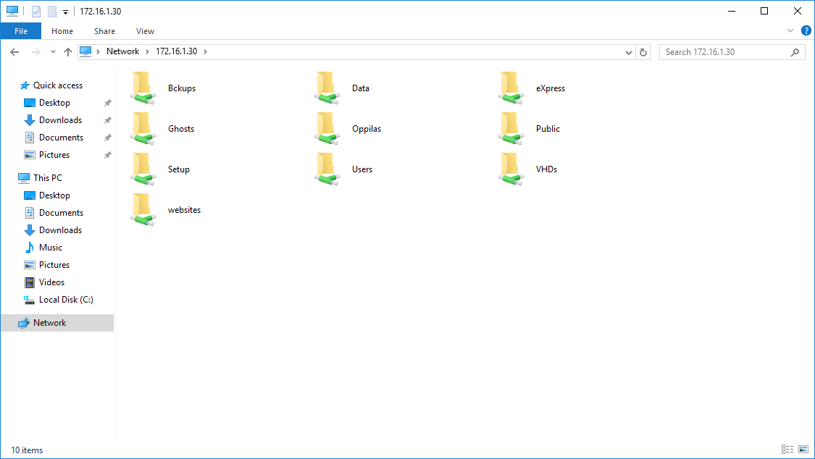

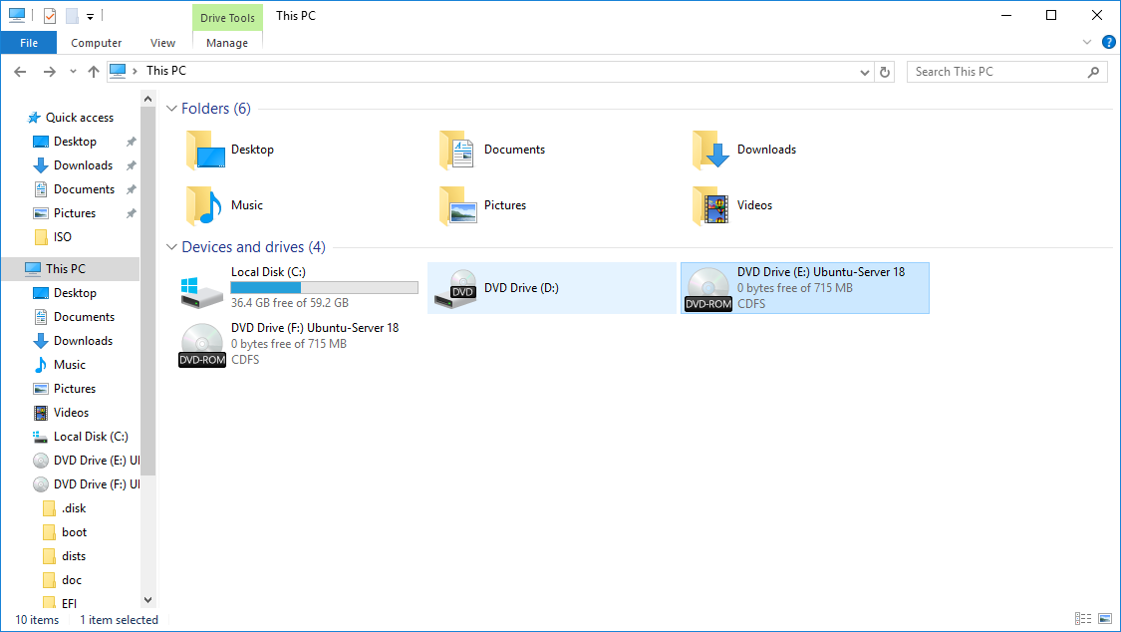

- In the **Hyper-V Manager**, open **VM-YourName** settings and

o Change the startup memory amount to **512 MB** and set the maximum memory amount to **2048 MB**

▪ Also investigate the other settings and their meaning: **memory buffer** and **memory weight** (no need to change the default settings)

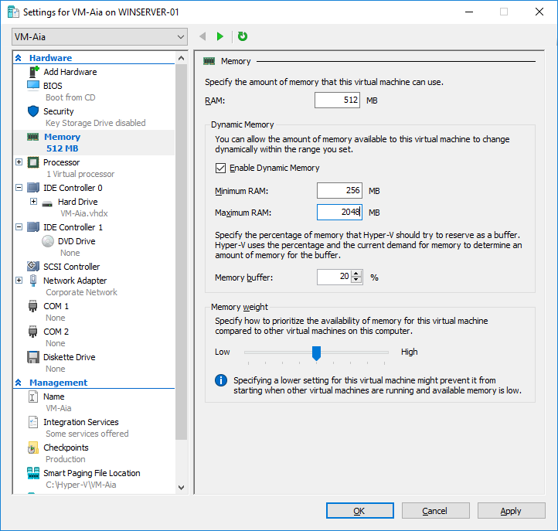

*In* ***your report****, explain what these features mean. Give some examples in what kind of situations you might use them.*

**A: Memory buffer: is the percentage of memory that Hyper -V should allocate to the VMs as a buffer, the value can be configured within 5-200% range with 20 % set by default.**

**The Hyper -V host uses the current VM demand for memory to figure out how much memory for the buffer it should be reserving.**

**Memory weight: The priority that setting for the VM compared to other VMs running on the same Hyper -V host.**

o Change the number of virtual processors to 2

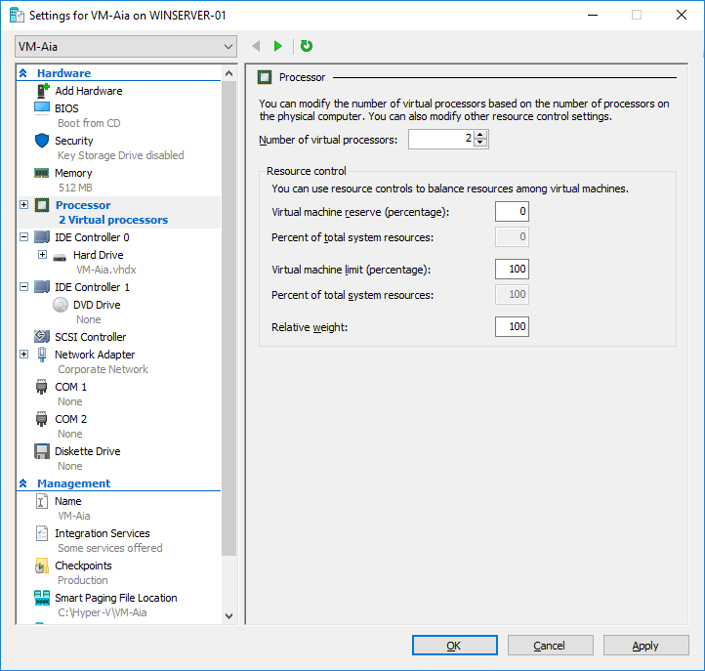

o Check the current hard drive configuration: in what bus it is connected and what is the current size

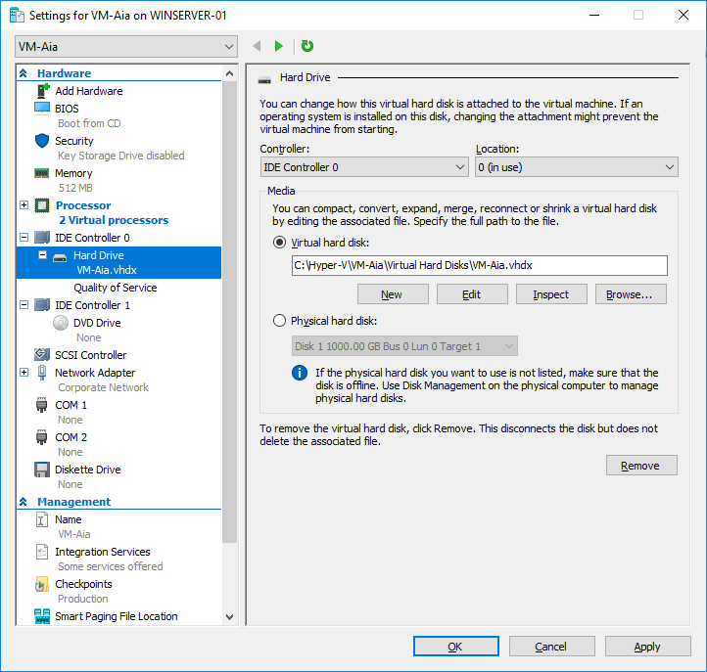

o Limit the network bandwidth to **10 Mbps** (both minimum and maximum)

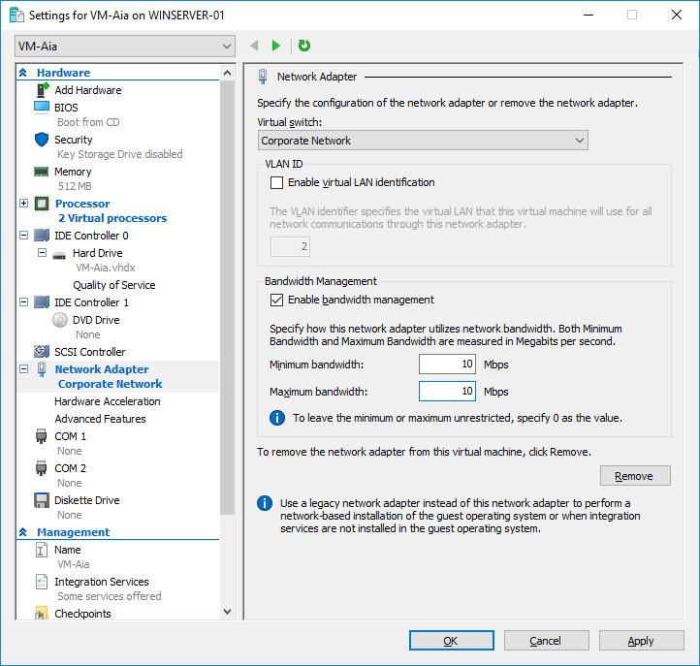

o Turn on the **DHCP guard** and **router advertisement guard** networking features

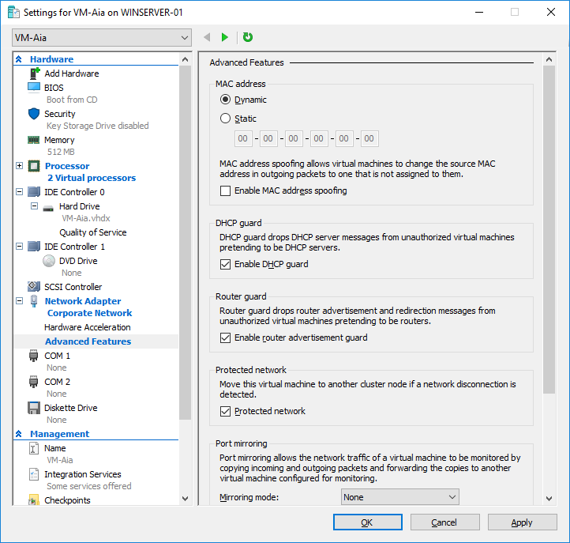

*In* ***your report****, explain what do these features mean and how do they protect the VM?*

**A: DHCP Guard: is a security feature that drops DHCP server messages from unauthorized virtual machines pretending to be DHCP servers.**

**Router Guard: is a security feature that drops Routers Advertisement and Redirection messages from unauthorized virtual machines pretending to be routers.**

o Change the automatic start action to always start the virtual machine automatically with delay of 60 seconds

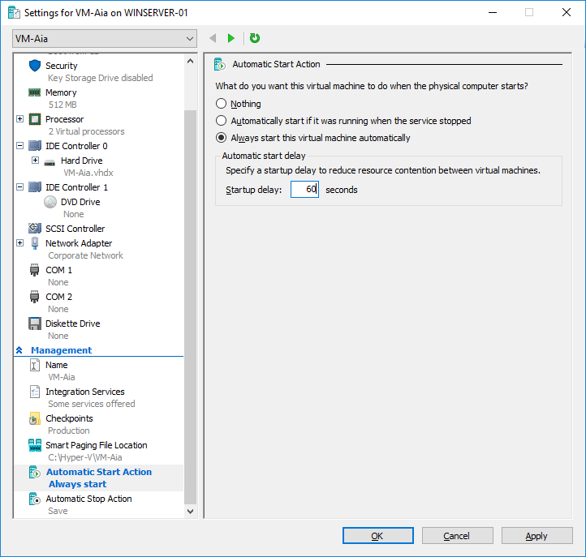

o Add a DVD drive and use the physical drive, where you mounted the Linux installation DVD

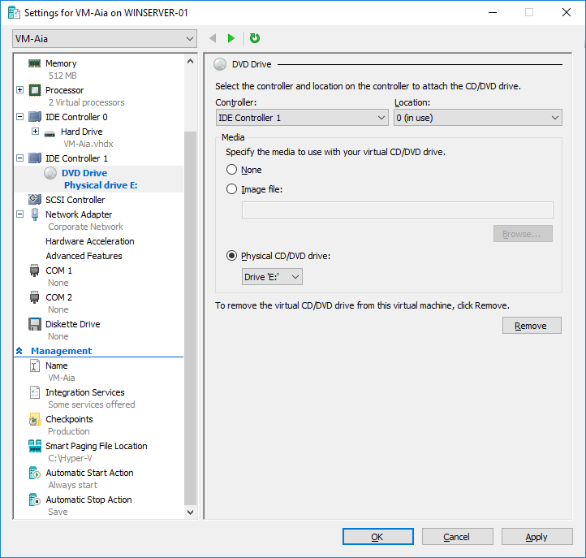

o Add a new hard disk with the following settings:

▪ Disk type: **Dynamically expanding**

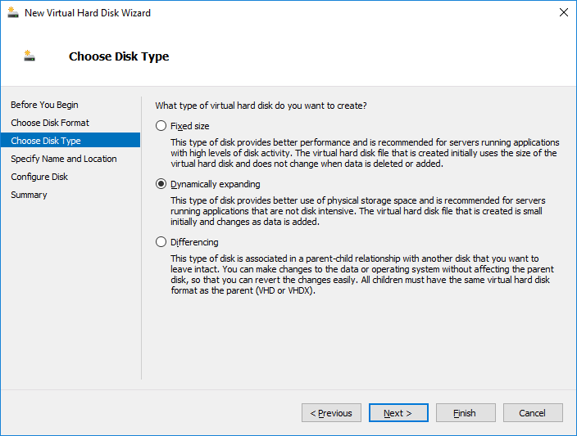

▪ Name: **VM-YourName-disk2.vhdx** in location **C:\Hyper-V\Virtual Hard Disks\**

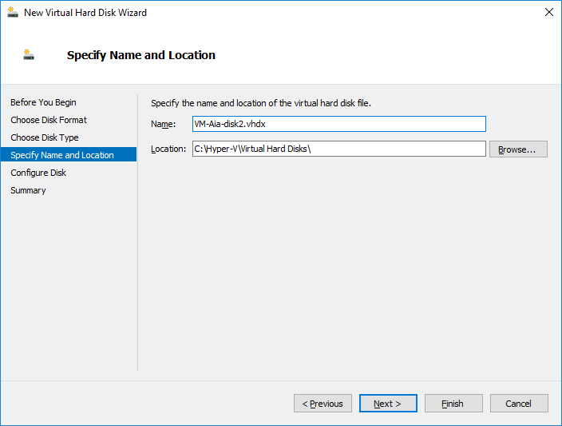

▪ Size: **5 GB**

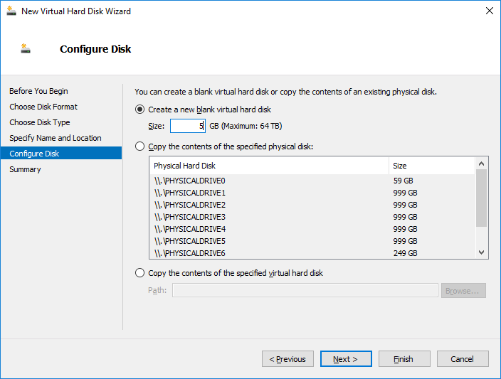

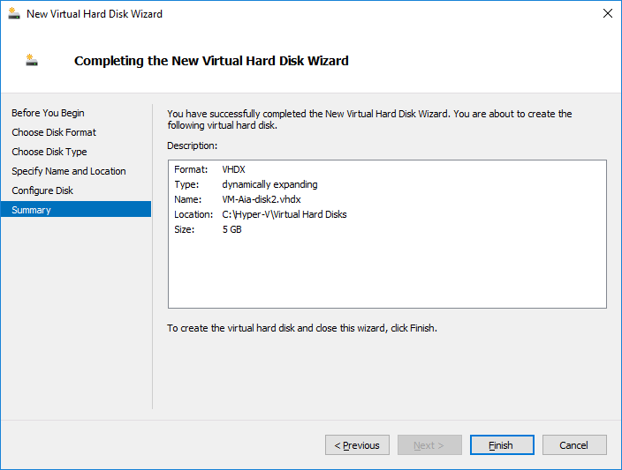

*In* ***your report****, explain the differences between* ***fixed****,* ***dynamically expanding*** *and* ***differencing*** *disks. Give one example for each, in which kind of situation that disk type would be useful.*

**A: Fixed size disk: the space is reserved beforehand when the fixed-size virtual hard disk is created, for example when VHDX created of 200 GB then 200 GB space will be reserved for the hard disk of the host.**

**Dynamically expanding disk: a small space is reserved on the host when dynamically expanding virtual hard disk is created, for example if it creates a 200 GB virtual hard disk for the VM, it will look like that the VM has although 200 GB virtual hard disk but only a small amount of space will be taken up from the hard disk of the host.**

**Differencing disk: are used in parent- child relationship, data is written to the child virtual disk keeping the parent disk in read only. It could be a sys prepped operating system in the parent disk and multiple virtual machines using the child disk, each VM uses its own differencing disk and writes data in it while the OS binaries are placed on shared parent disk.**

o Configure the VM boot order to try booting first from the DVD drive

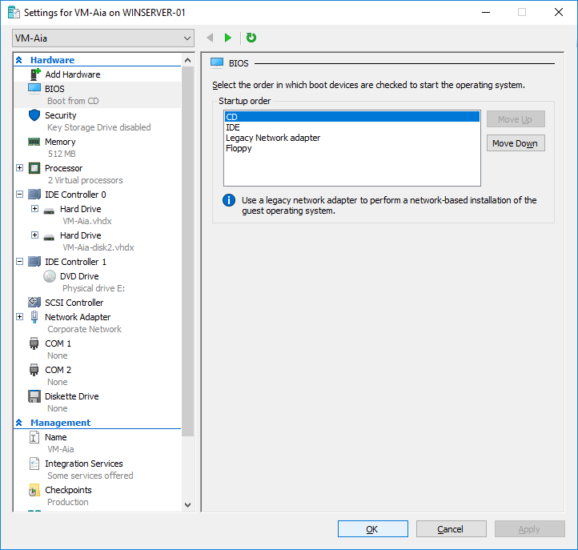

- Also practice VM configurations with the PowerShell. Open **Windows PowerShell** (you can use the ISE if you wish), import the **Hyper-V module**, and then use the command **New-VM** to create a new virtual machine with the following settings:

o Name **VM-YourName-2**

o Startup Memory 32 MB

o New VHD path **C:\Hyper-V\Virtual Hard Disks\VM-YourName-2.vhdx**

o New VHD size **10 GB**

o Connection **Private Network**

o *Copy-paste the command and its output to* ***your report****.*

New-VM -NewVHDPath "C:\Hyper-V\Virtual Hard Disks\VM-Aia-2.vhdx" -NewVHDSizeBytes 10737418240 -MemoryStartupBytes 33554432 -Name VM-Aia-2 -SwitchName "Private Network"

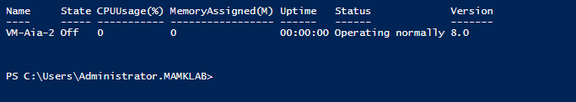

o Then, check in the **Hyper-V Manager** that the VM was created successfully. Also browse through the settings and see what kind of defaults were used (don’t change any settings).

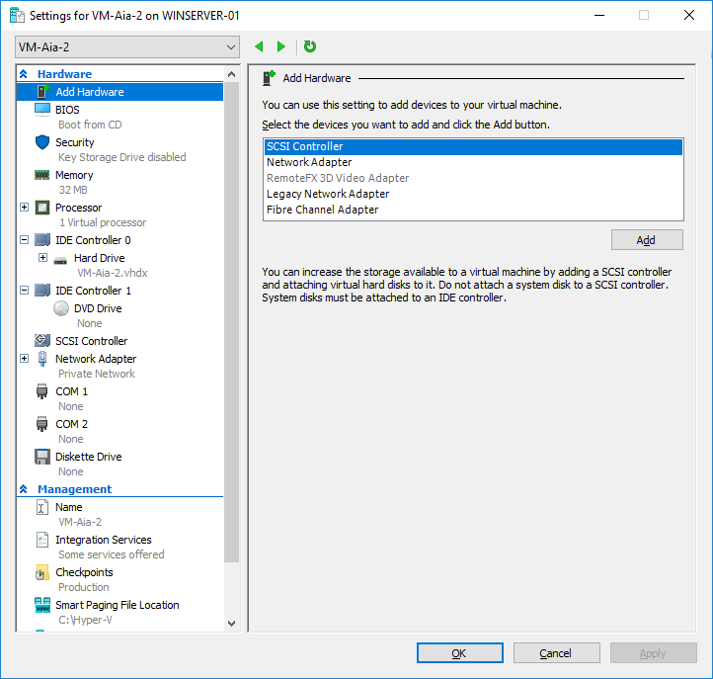

o Continue gathering information on VM environment in the **PowerShell**, use at least the following commands

* Get-Command -Module Hyper-V

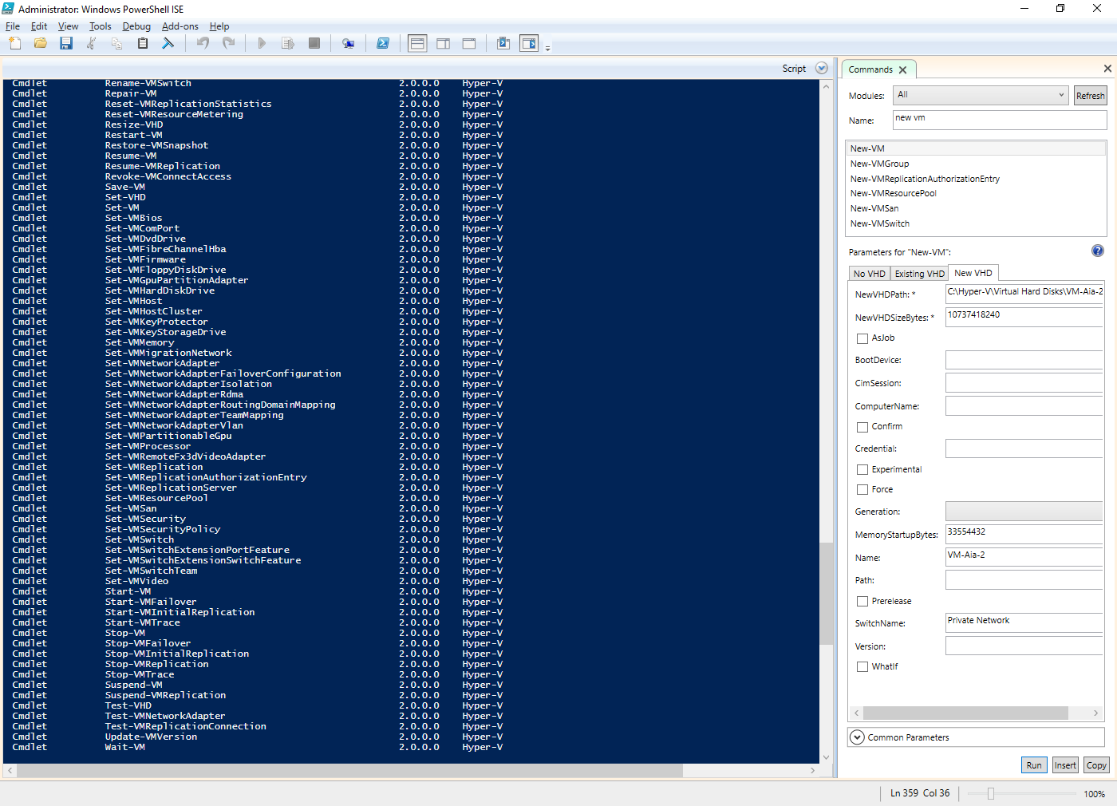

* Get-VM

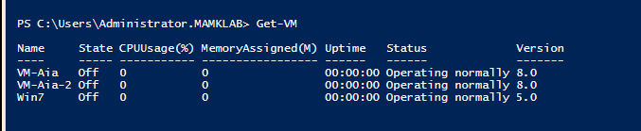

* Get-VM VM-YourName-2

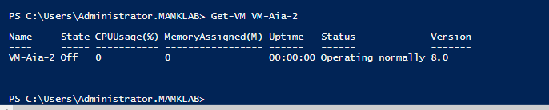

* Get-VM VM-YourName-2 |select *

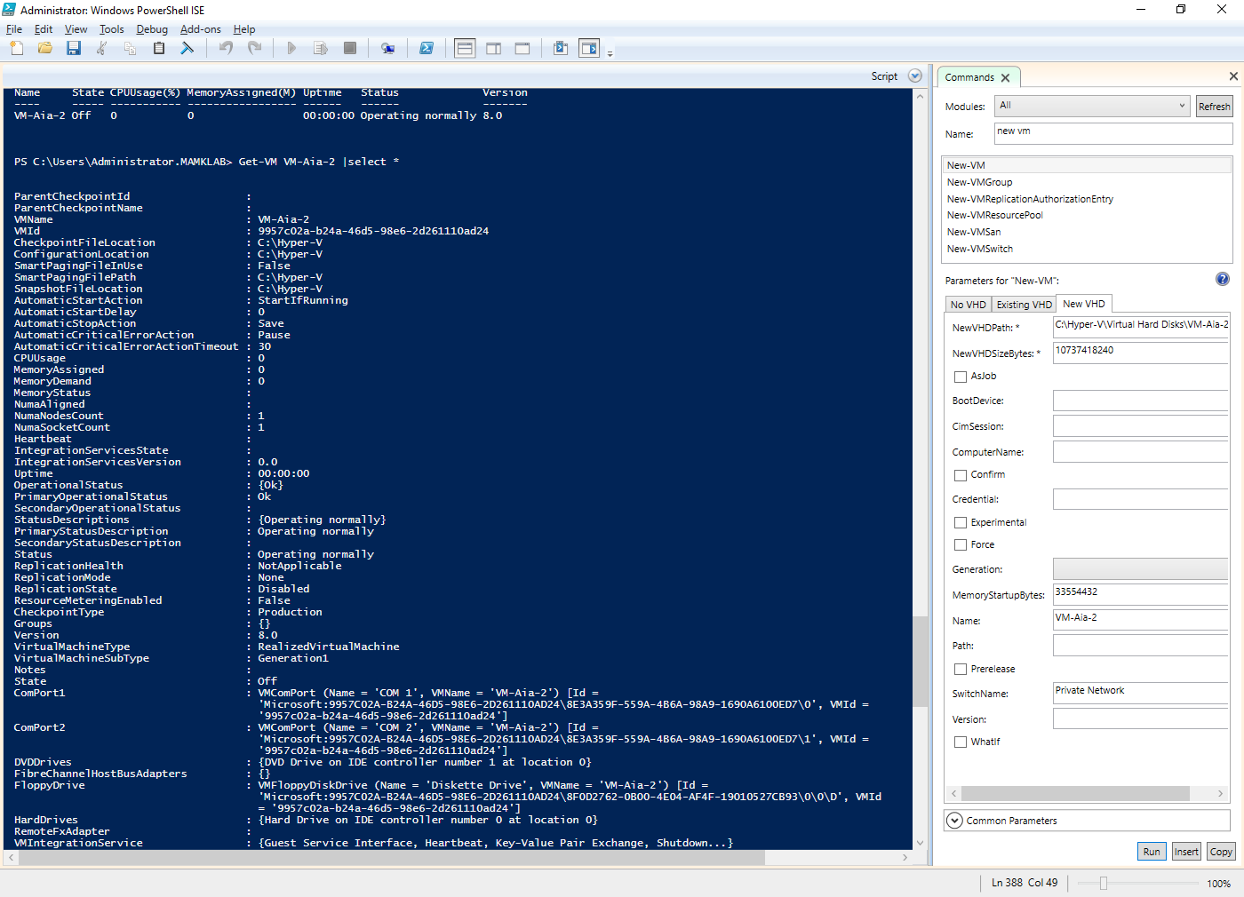

* **Get-VM | select -ExpandProperty NetworkAdapters**

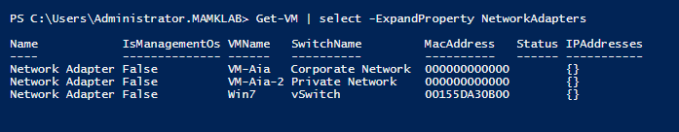

* Get-VMSwitch

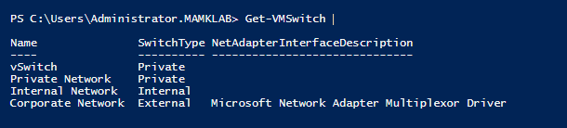

* Get-VMHost

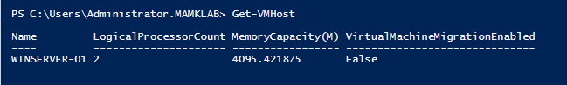

* Get-VMHost |select *

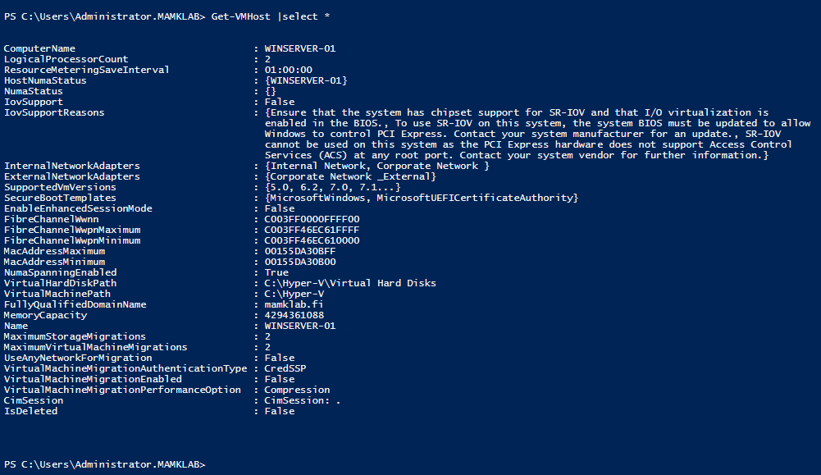

* **Get-VHD -Path "C:\Hyper-V\Virtual Hard Disks\ VM-YourName-2.vhdx"**

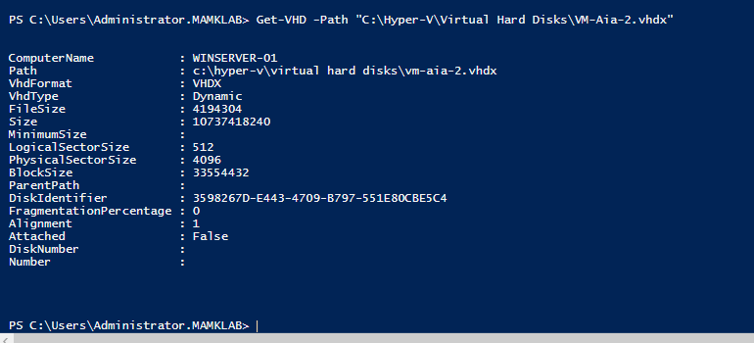

o Continue configuring the **VM-YourName-2** in **PowerShell** and do the following settings:

▪ Check the full VM information with the command **Get-VM -Name VM-YourName-2 |fl \***

▪ Set the **processor count** to 2

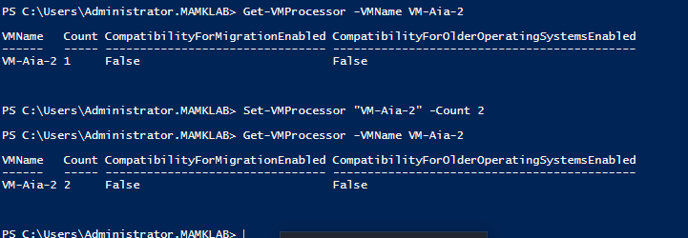

▪ Enable **dynamic memory**

Set-VMMemory "VM-Aia-2" -DynamicMemoryEnabled $true

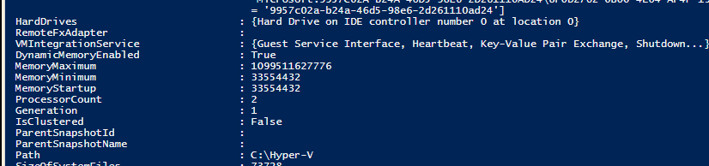

o In **PowerShell**, start the **VM-YourName-2**

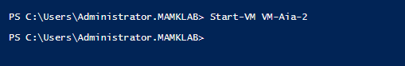

**Step 3. Checkpoints (snapshots)**

- *In* ***your report****, explain what a virtual machine snapshot (checkpoint) is. What kind of advantages there are and why snapshots are useful? What kind of challenges or problems the snapshots may introduce? Also explain what it means from the storage viewpoint in practice: how do the snapshots affect the usage of the virtual hard drives (the .vhdx files).*

**A: Physically, a hyper -V checkpoint is a differencing virtual hard disk that has a special name and vhdx extension and a configuration xml file with GUID name, once the checkpoint is taken the differencing vhdx disk becomes a place where temporary changes to the VM’s original disk are stored while an original disk remains read only.**

**Logically, it’s a consistent state of a VM in a specific point in time, it could preserve this state for a while and revert to it if something happened with the current state of a VM, like backup.**

**Checkpoint being stored on a production datastore along with VM hard disks, the datastore still happens to be a single point of failure in the system, any problem occurring with the datastore leaves without a VM.**

**It may slow down the entire host as long as it’s keeping, and they are lost when the VM’s virtual disk is damaged.**

- In **Hyper-V Manager**, open a Connection to **VM-YourName** and power it on

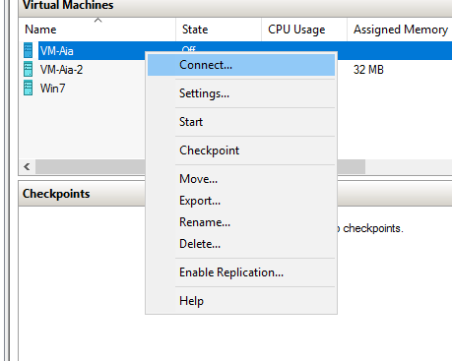

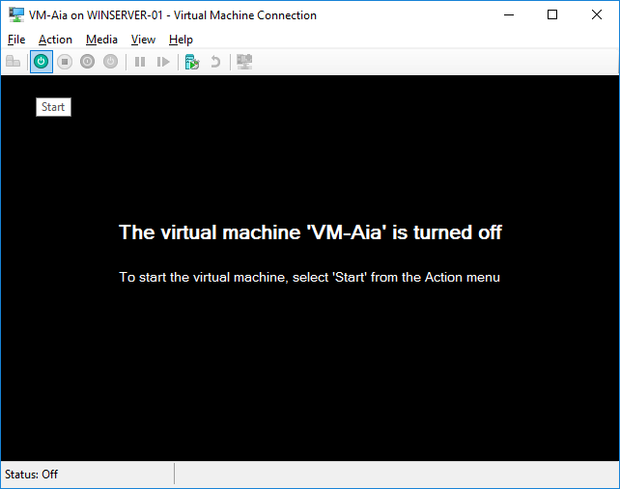



- Test running the Linux Live mode in the VM (no need to actually install the Linux)

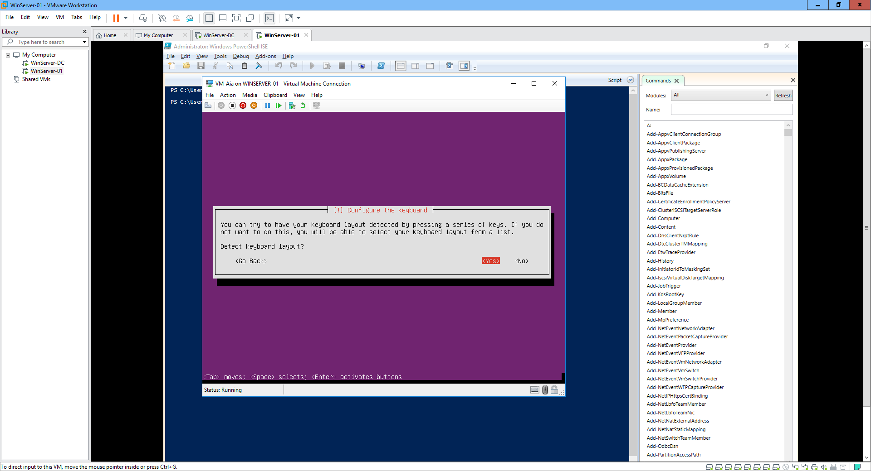

- Take a **checkpoint** (snapshot) from the VM and name the checkpoint as **Linux-testing**

Get-VM -Name VM-Aia | Checkpoint-VM -SnapshotName “LinuxTesting”

- Do some changes in the Linux (for example start some application and create some files to the desktop) and take another checkpoint

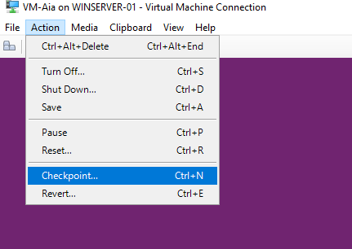

- In **Hyper-V Manager**’s **Checkpoints** manager, see that the checkpoints you took are now visible

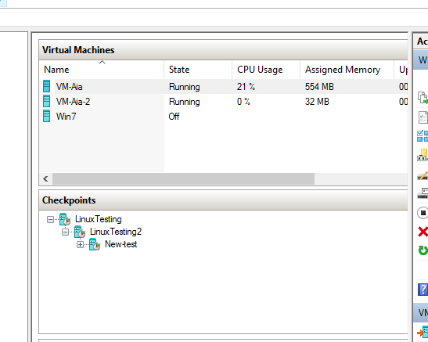

- Also see the checkpoints in **PowerShell**: **Get-VMSnapshot \***

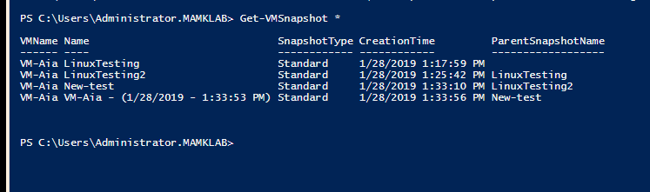

- Test **reverting** the VM to a previous state

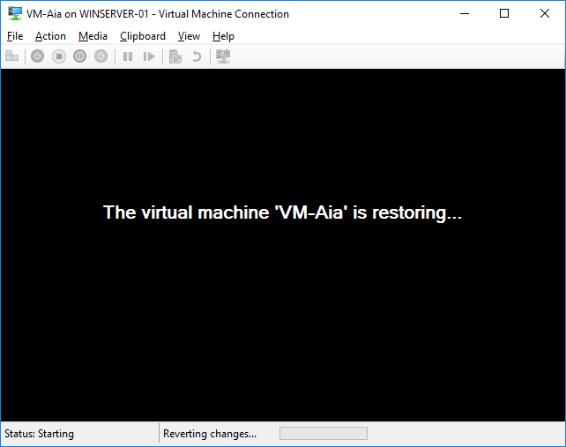

- Also take a checkpoint of **VM-YourName-2** in the **PowerShell** and practice reverting to it

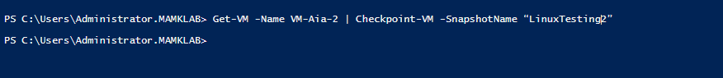

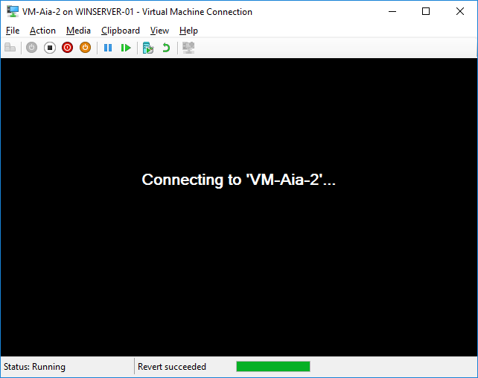

- When you are ready, stop **VM-YourName-2** in the **PowerShell** and **VM-YourName** in the **Hyper-V Manager**

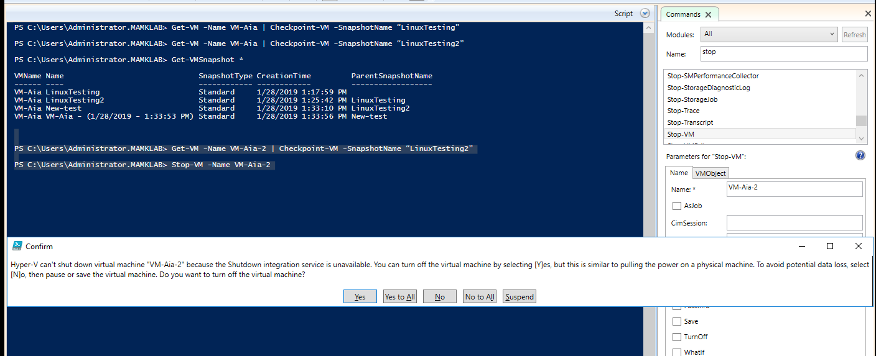

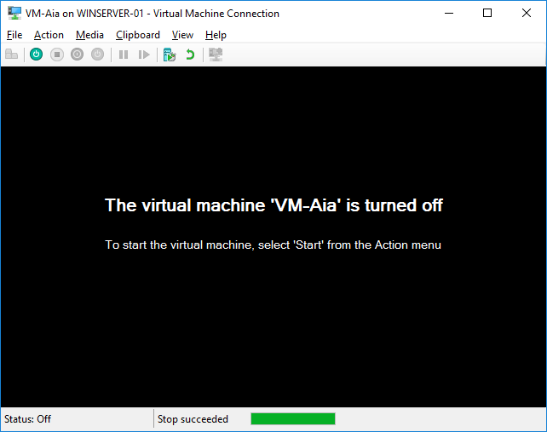

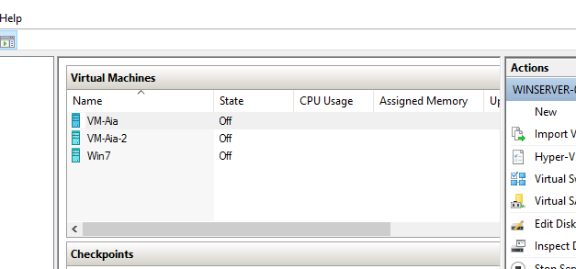

Finally, describe **in your report** your personal experiences about doing the lab and your experiences of working with the Hyper-V virtualization tools (both in GUI and command line).

**A:** **With Hyper -V IT administrator can essentially multiply computing resource by adding virtual machines using Hyper -V to bolster the amount of work than can be accomplished without adding a new physical hardware. It saves money and time compared to upgrading costly hardware. VM machines controlled through Hyper -V uses virtual hard drives, virtual switches and other virtual components to allow users to run their workload under a wide range of conditions.**